**Module 5: Critical Thinking Assignment**

https://github.com/damansandhu/CSU_Global_Module_5_Critical_Thinking_Assignment

**Part 1: Average Rainfall Calculation**

**Pseudocode:**

1. **Initialize Variables:**
   * Set total_rainfall = 0
   * Set total_months = 0
2. **Input:**
   * Prompt the user: "Enter the number of years"
   * Store the input as years
3. **Outer Loop (for each year):**
   * For year in range from 1 to years:
     + Display "Year year:"

**Inner Loop (for each month):**

* + - For month in range from 1 to 12:
      * Prompt the user: "Enter the inches of rainfall for month month"
      * Store the input as monthly_rainfall
      * Add monthly_rainfall to total_rainfall
      * Increment total_months by 1

1. **Calculate Average:**
   * Set average_rainfall = total_rainfall / total_months
2. **Output:**
   * Display "Number of months: total_months"
   * Display "Total inches of rainfall: total_rainfall"
   * Display "Average rainfall per month: average_rainfall"

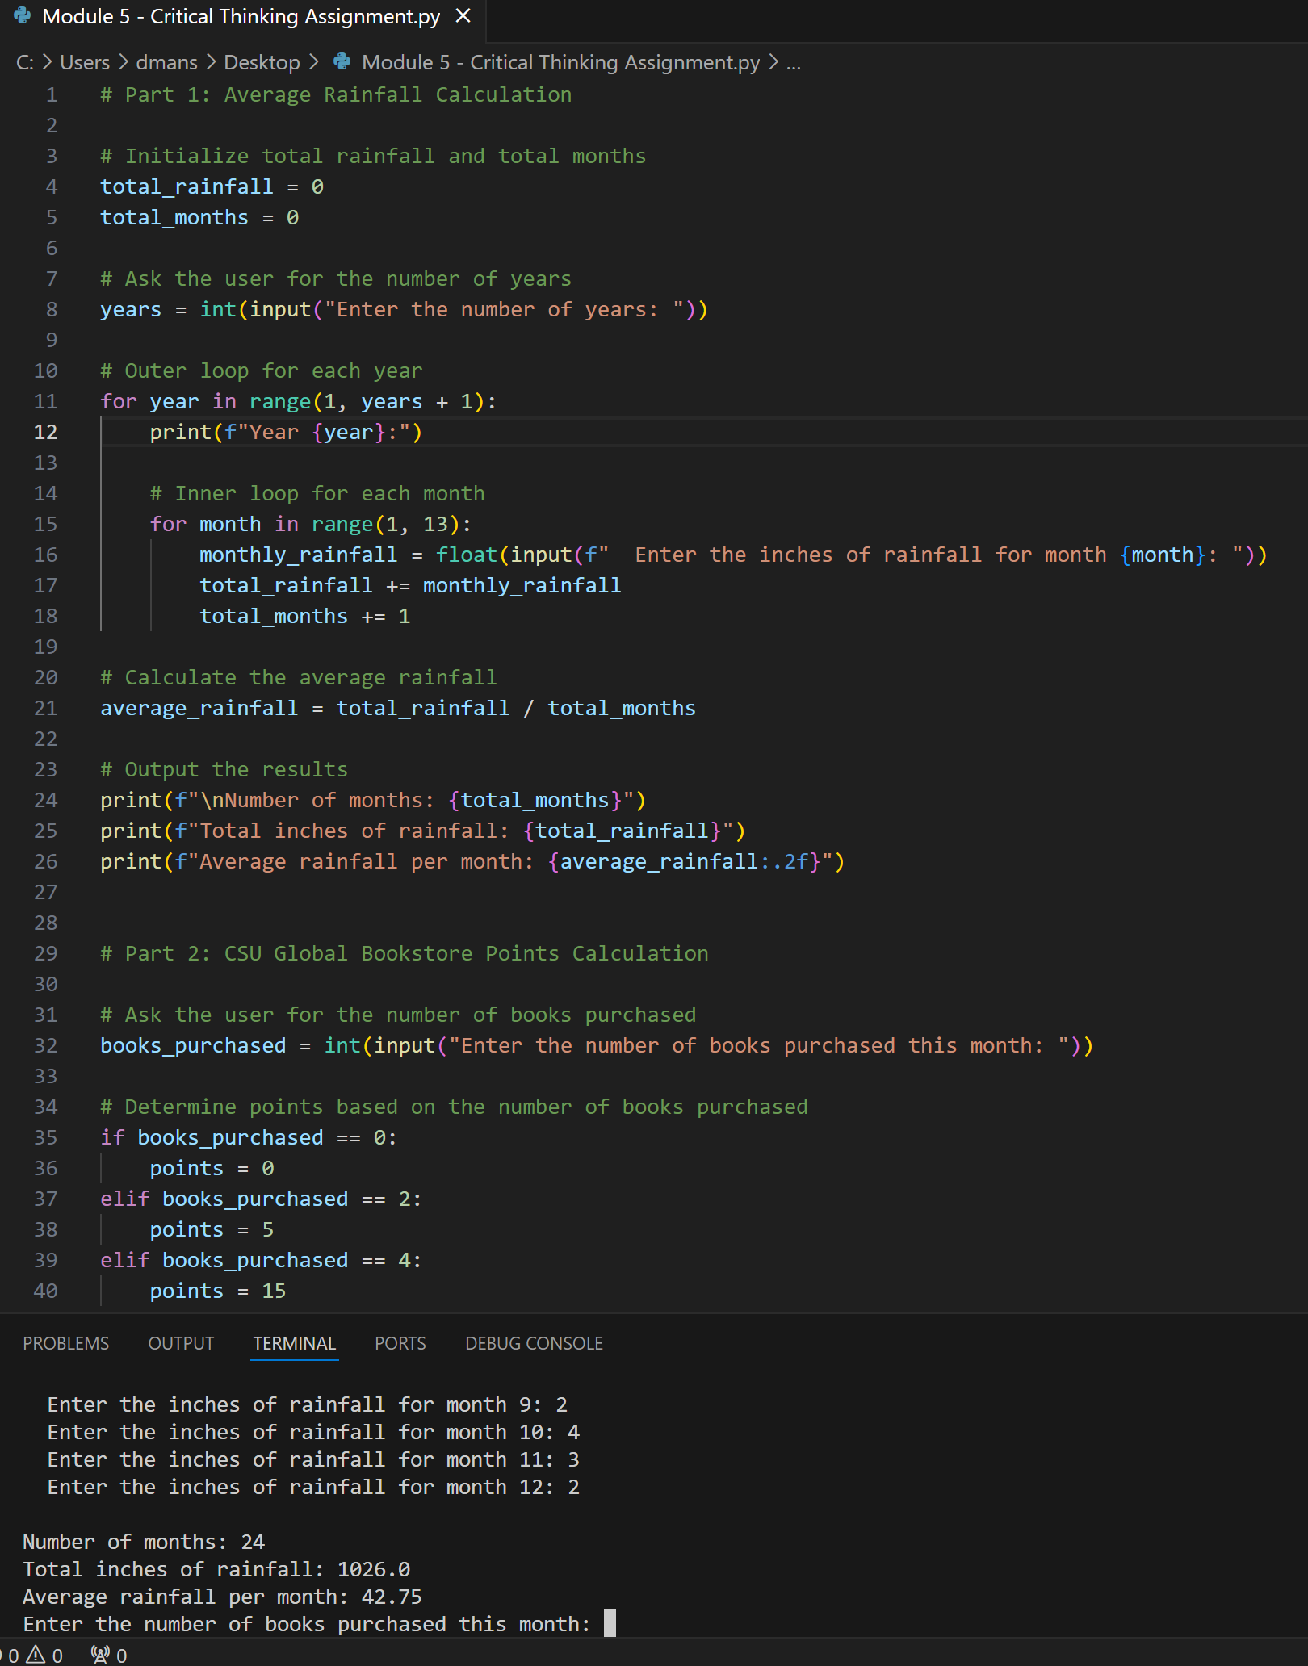

**Part 2: CSU Global Bookstore Points Calculation**

**Pseudocode:**

1. **Input:**
   * Prompt the user: "Enter the number of books purchased this month"
   * Store the input as books_purchased
2. **Conditionals:**
   * If books_purchased is 0, then:
     + Set points = 0
   * Else if books_purchased is 2, then:
     + Set points = 5
   * Else if books_purchased is 4, then:
     + Set points = 15
   * Else if books_purchased is 6, then:
     + Set points = 30
   * Else if books_purchased is 8 or more, then:
     + Set points = 60
   * Otherwise:
     + Set points = 0
3. **Output:**
   * Display "Points awarded: points"

